Exploratory Data Analysis Report
SCADA Time Series — Wind Turbine T1 (Dataset: T1.csv)
Dataset inferred to be 10-minute resolution SCADA data from a single wind turbine over the full calendar year 2018, covering active power output, wind speed, a theoretical (manufacturer) power curve reference, and wind direction. This characterization was derived from the data itself, not assumed a priori: 10-minute regular timestamp spacing, four numeric sensor-style variables, an active-power series bounded near a fixed rated capacity, and a strong monotonic wind-speed-to-power relationship matching a standard turbine power curve.
Report generated: July 22, 2026.

1. Dataset Overview

1.1 Shape, Columns and Types
Property | Value
Rows (samples) | 50,530
Columns (features) | 5 (1 timestamp + 4 numeric)
Date/Time | string, parsed as datetime (format: DD MM YYYY HH:MM)
LV ActivePower (kW) | float64
Wind Speed (m/s) | float64
Theoretical_Power_Curve (KWh) | float64
Wind Direction (°) | float64
Time span | 2018-01-01 00:00 → 2018-12-31 23:50 (full calendar year)
Nominal sampling interval | 10 minutes

1.2 Missing Values and Duplicates
- No missing (NaN) cell values in any of the 5 columns — 0 across the board.
- No fully duplicated rows (0 duplicates).
- However, the timestamp grid itself is not perfectly regular: 50,530 rows exist but a fully regular 10-minute grid over the year would contain 52,560 slots. Differencing consecutive timestamps shows 50,497 steps of exactly 10 minutes, and 33 irregular gaps (11 of 20 min, 2 of 40 min, and one large gap of 4 days 8 h 20 min between 2018-01-26 06:20 and 2018-01-30 14:40).
Evidence: df['Date_Time_parsed'].diff().value_counts() shows the dominant 10-min spacing with a long tail of larger gaps; total implied missing 10-minute slots ≈ 2,030.
Hypothesis (needs further validation): The large 4-day gap in late January is consistent with a maintenance outage or a data-logging/telemetry interruption at the SCADA system rather than a true turbine value of zero; this should be confirmed against turbine maintenance logs if available.

1.3 Descriptive Statistics
Variable | Mean | Std | Min | 25% | Median | 75% | Max
Active Power (kW) | 1307.7 | 1312.5 | -2.47 | 50.7 | 825.8 | 2482.5 | 3618.7
Wind Speed (m/s) | 7.56 | 4.23 | 0.00 | 4.20 | 7.10 | 10.30 | 25.21
Theoretical Power (kWh) | 1492.2 | 1368.0 | 0.00 | 161.6 | 1063.8 | 2964.9 | 3600.0
Wind Direction (°) | 123.7 | 93.4 | 0.00 | 49.3 | 73.5 | 201.7 | 360.0
Rated capacity: the active-power maximum (3618.7 kW) and the theoretical curve's flat ceiling of exactly 3600 kWh both point to a turbine with a nameplate capacity around 3.6 MW.

2. Data Quality Assessment

2.1 Missing-Value Analysis
Covered in Section 1.2 — no cell-level NaNs, but ~33 gap events in the timestamp index (~2,030 missing 10-minute slots, dominated by one 4-day outage). Any time-series modeling should reindex to a full 10-minute grid and explicitly mark/interpolate these gaps rather than treat the data as perfectly contiguous.

2.2 Outlier Detection
Variable | IQR-rule outliers | Z-score>3 outliers | Note
Active Power (kW) | 0 (0.00%) | 0 | Bounded variable near [0, 3619]; IQR fences fall outside the physical range
Wind Speed (m/s) | 423 (0.84%) | 228 | High-wind-speed tail (storms/gusts up to 25.2 m/s)
Theoretical Power (kWh) | 0 (0.00%) | 0 | Bounded/clipped at 3600
Wind Direction (°) | 0 (0.00%) | 0 | Circular variable — IQR is not a meaningful outlier test here
Evidence: IQR fences and z-score>3 computed directly on the raw columns.
Hypothesis (needs further validation): Standard IQR/z-score outlier tests are not well suited to Wind Direction (circular, 0°≈360°) or to Active Power (physically bounded, right-skewed by the S-shaped power curve). A more appropriate treatment is deviation from the expected power curve at a given wind speed (see Section 2.4/6) rather than univariate outlier rules.

2.3 Constant / Near-Constant Variables
- No constant variables. Coefficient of variation: Active Power 1.00, Wind Direction 0.76, Theoretical Power 0.92, Wind Speed 0.56 — all show substantial spread, none flagged as near-constant.
- Unique-value counts are high relative to row count (Wind Speed: 50,305 unique of 50,530; Wind Direction: 50,251; Active Power: 38,764; Theoretical Power: 37,157), indicating genuinely continuous sensor signals rather than quantized or placeholder values.

2.4 Noise Inspection and Data Consistency
- 57 rows have slightly negative Active Power (min = -2.47 kW). This is physically implausible for power generation but numerically tiny — consistent with sensor noise/parasitic load draw while the turbine is idling, a common and normal SCADA artifact, not a data-corruption signal.
- 10,781 rows (21.3%) show Active Power = 0 kW. Of these, most correspond to low/no wind (Wind Speed ≤ cut-in, ~3-4 m/s), which is expected.
- 1,788 rows show Active Power ≈ 0 kW while Wind Speed > 4 m/s (i.e., above typical cut-in) — a clear inconsistency with the theoretical power curve. Grouping these into contiguous runs yields 231 distinct shutdown episodes (median length 2 samples ≈ 20 min, but ranging up to 267 samples ≈ 44.5 hours).
Evidence: df[(power<=0) & (wind_speed>4)] isolated 1,788 rows; run-length grouping on the boolean flag found 231 episodes with a long-tailed duration distribution (mean 7.7 samples, max 267 samples).
Hypothesis (needs further validation): These zero-power/high-wind episodes most likely represent curtailment, maintenance downtime, or grid-connection faults rather than sensor error, since they cluster into sustained episodes (up to ~44 hours) rather than being scattered single-sample noise. Cross-referencing with a turbine status/fault code (not present in this file) would confirm this.

3. Distribution Analysis
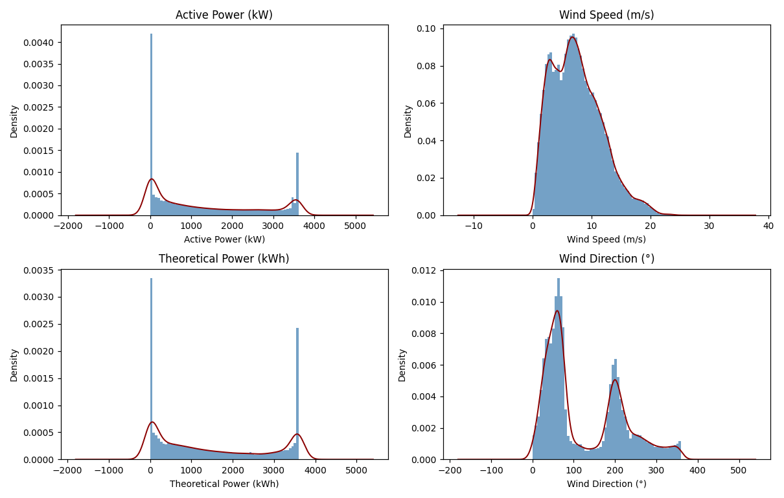
Figure 1. Histograms with kernel density overlays for all four numeric variables.
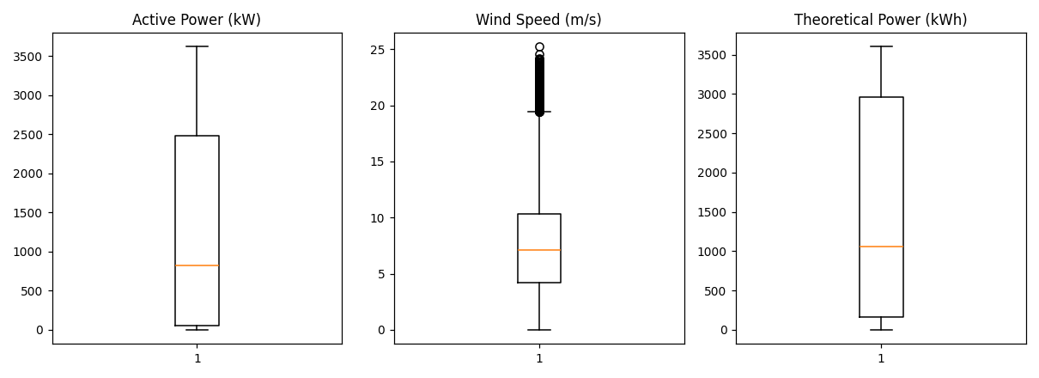
Figure 2. Boxplots — Active Power, Wind Speed, Theoretical Power.
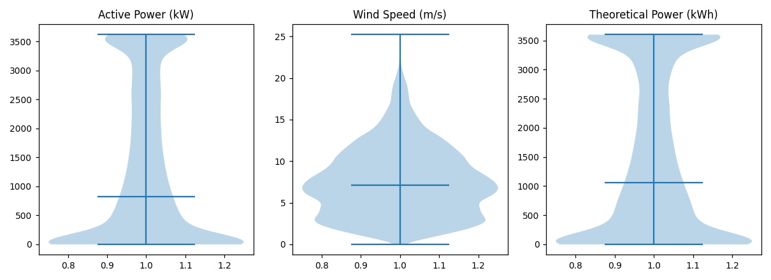
Figure 3. Violin plots showing the full shape of each distribution.

3.1 Quantile Summary
Variable | 1% | 5% | 25% | 50% | 75% | 95% | 99%
Active Power (kW) | -2.4 | 0.0 | 50.7 | 825.8 | 2482.5 | 3396.6 | 3603.6
Wind Speed (m/s) | 1.7 | 2.5 | 4.2 | 7.1 | 10.3 | 15.0 | 19.2
Theoretical Power (kWh) | 0.0 | 0.0 | 161.6 | 1063.8 | 2964.9 | 3600.0 | 3600.0
Wind Direction (°) | 3.8 | 15.0 | 49.3 | 73.5 | 201.7 | 331.0 | 351.2

3.2 Skewness and Kurtosis
Variable | Skewness | Kurtosis (excess) | Interpretation
Active Power (kW) | 0.60 | -1.16 | Right-skewed, platykurtic (flatter than normal) — mass piles at low power (calm/idle) with a long right tail toward rated capacity
Wind Speed (m/s) | 0.62 | 0.06 | Right-skewed, close to mesokurtic — classic Weibull-like wind speed shape
Theoretical Power (kWh) | 0.42 | -1.41 | Right-skewed and strongly platykurtic — reflects the clipped/flat ceiling at 3600
Wind Direction (°) | 0.70 | -0.75 | Right-skewed, platykurtic — direction is not uniformly distributed (prevailing-wind effect, see Fig. 16)
Evidence: scipy.stats.skew / kurtosis computed on the full columns (Fisher definition, excess kurtosis).

4. Relationship Analysis
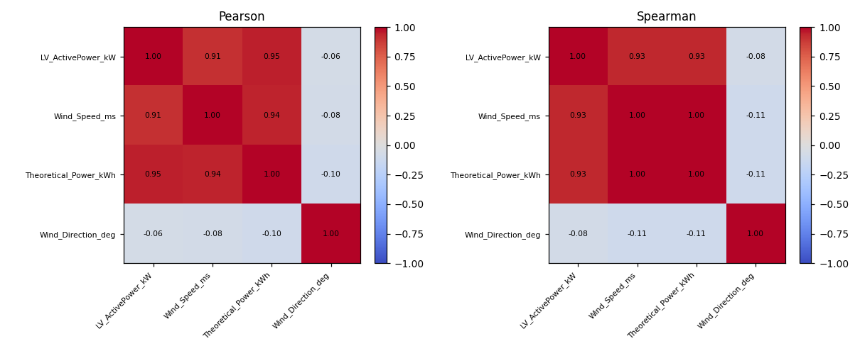
Figure 4. Pearson (left) and Spearman (right) correlation matrices.

4.1 Correlation Matrix
Pair | Pearson r | Spearman ρ
Active Power ↔ Wind Speed | 0.913 | 0.933
Active Power ↔ Theoretical Power | 0.950 | 0.934
Active Power ↔ Wind Direction | -0.063 | -0.078
Wind Speed ↔ Wind Direction | -0.077 | -0.107 (approx.)
Active Power is very strongly correlated with both Wind Speed and the Theoretical Power Curve, as physically expected (Spearman slightly exceeds Pearson for Power↔Speed, consistent with a monotonic but non-linear — S-shaped — relationship rather than a strictly linear one). Wind Direction is only weakly related to power output on its own, suggesting direction matters mainly through interaction effects (e.g., wake losses from neighboring turbines at specific bearings) rather than a direct linear driver.

4.2 Pairwise Relationships
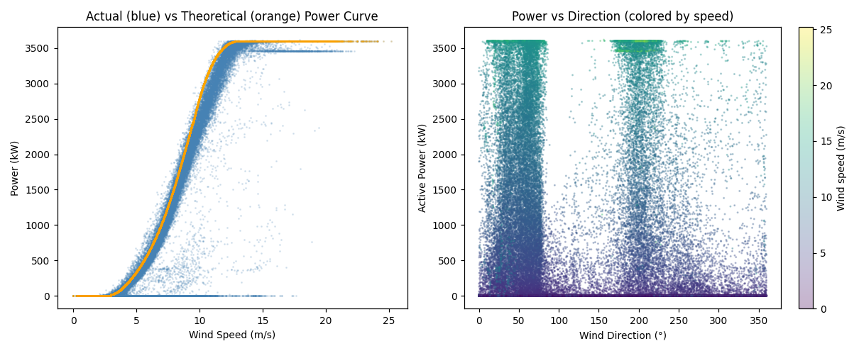
Figure 5. Left: actual power (blue) vs. theoretical power curve (orange) against wind speed, showing the canonical S-curve with cut-in (~3-4 m/s), steep ramp, and rated-power plateau (~12-25 m/s) — plus a visible cloud of under-performance below the theoretical curve. Right: power vs. wind direction, colored by wind speed, showing power concentrates at two prevailing-direction sectors.
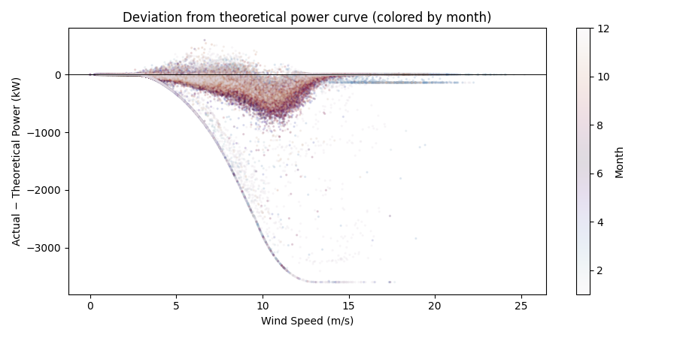
Figure 15. Deviation of actual from theoretical power vs. wind speed, colored by month. The dense negative-deviation band in the mid wind-speed range highlights curtailment/under-performance events distributed across the year.
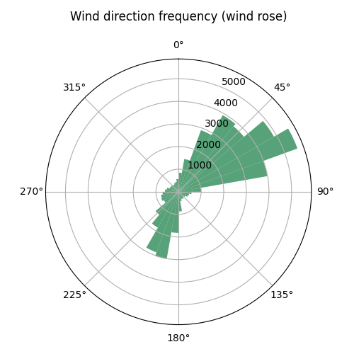
Figure 16. Wind-direction frequency (wind rose). Wind is not uniformly distributed by direction — two dominant sectors emerge, roughly opposite each other, typical of a site with a prevailing wind axis.

4.3 Mutual Information
Feature | Mutual Information with Active Power
Wind Speed | 1.966
Theoretical Power | 1.928
Wind Direction | 0.196
Mutual information (which also captures non-linear dependence) confirms the correlation picture: Wind Speed and Theoretical Power carry almost 10x more shared information with Active Power than Wind Direction does.

5. Time-Series Exploration
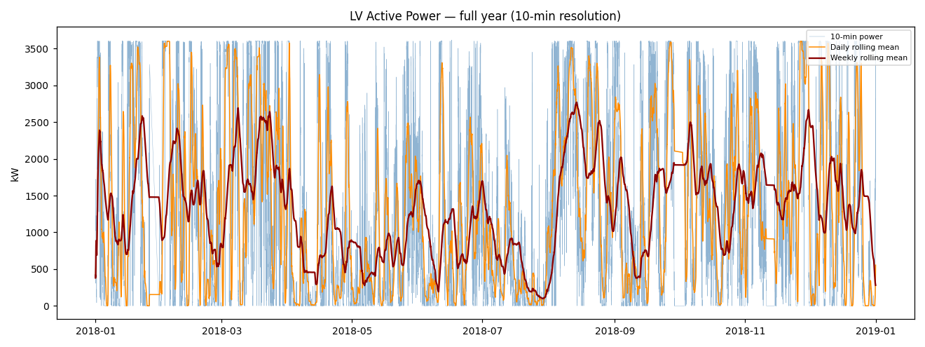
Figure 6. Full-year Active Power series (thin blue) with 1-day rolling mean (orange) and 1-week rolling mean (dark red).
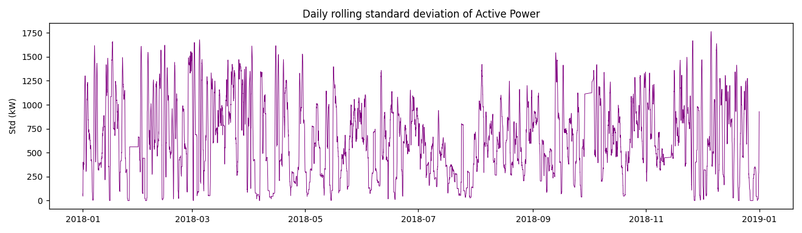
Figure 7. 1-day rolling standard deviation of Active Power — variance itself fluctuates through the year (volatility clustering).
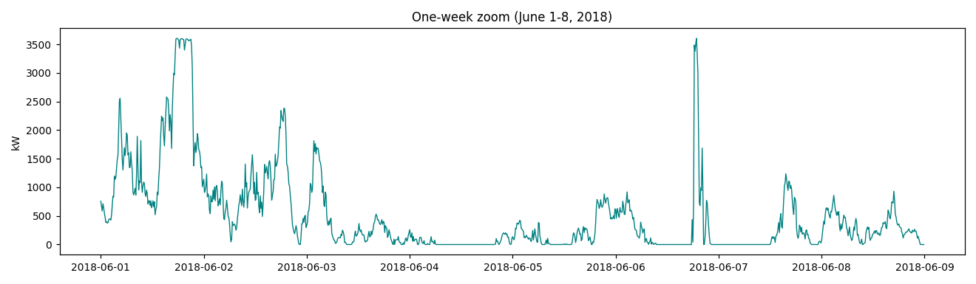
Figure 10. One-week zoom (June 1-8, 2018) showing high-frequency, irregular fluctuation superimposed on multi-day swings — no obvious repeating daily shape.
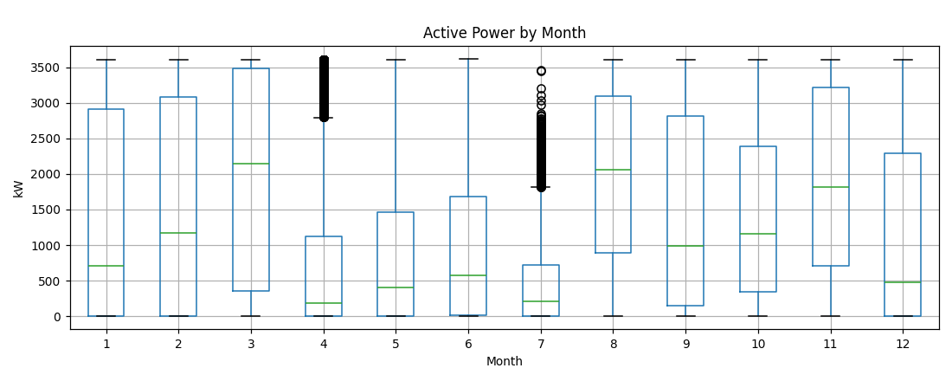
Figure 8. Active Power distribution by calendar month — a visible seasonal pattern (higher/more variable power in some months than others).
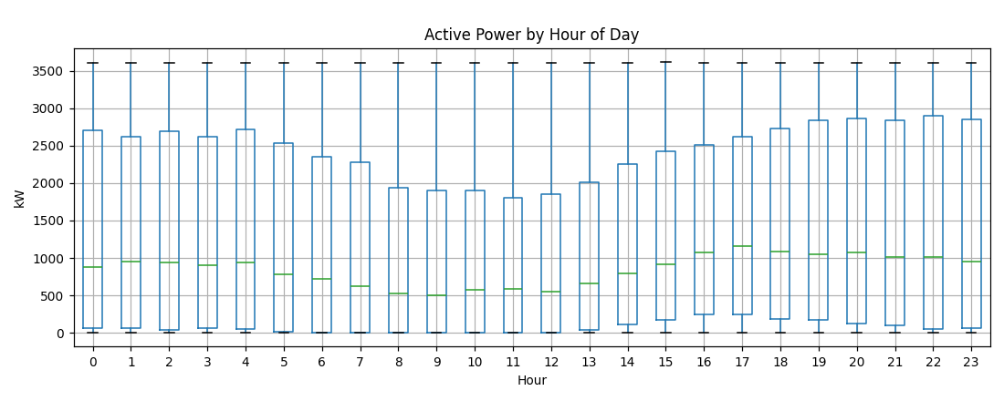
Figure 9. Active Power distribution by hour of day — medians are broadly similar across hours, i.e., only a weak diurnal (time-of-day) effect, consistent with wind (not solar) being the driver.

5.1 Trend and Seasonality
- The weekly rolling mean (Fig. 6) drifts noticeably across the year rather than sitting flat, and the monthly boxplots (Fig. 8) show shifting medians/spreads month to month — evidence of seasonal-scale structure in mean wind resource, not a fixed diurnal cycle.
- The hourly boxplot (Fig. 9) shows only mild variation in median power across hours of the day, so any diurnal component is weak relative to the seasonal/synoptic-scale (multi-day weather-system) variation.

5.2 Stationarity Tests
Test | Series | Statistic | p-value | Conclusion (5% level)
ADF (H0: unit root) | Raw 10-min Active Power | -14.01 | <0.0001 | Reject H0 → stationary
KPSS (H0: level-stationary) | Raw 10-min Active Power | 0.629 | 0.020 | Reject H0 → non-stationary (level)
ADF (H0: unit root) | Daily mean Active Power | -8.21 | <0.0001 | Reject H0 → stationary
KPSS (H0: level-stationary) | Daily mean Active Power | 0.234 | 0.10 (≥) | Fail to reject → consistent with stationary
Evidence: statsmodels.tsa.stattools.adfuller and kpss, with autolag='AIC' and automatic bandwidth selection respectively.
The raw 10-minute series gives a textbook 'ADF stationary / KPSS non-stationary' conflict. This combination is common for series with strong short-term autocorrelation and volatility clustering (heteroskedasticity) rather than an outright trend: ADF has power against a unit root but the KPSS test is sensitive to the slow-moving conditional mean created by multi-day weather patterns. At the daily-aggregate resolution the conflict disappears and both tests agree the series is stationary in level, supporting the interpretation that the raw series is trend-stationary / bounded rather than truly integrated (I(1)).

5.3 Autocorrelation (ACF) and Partial Autocorrelation (PACF)
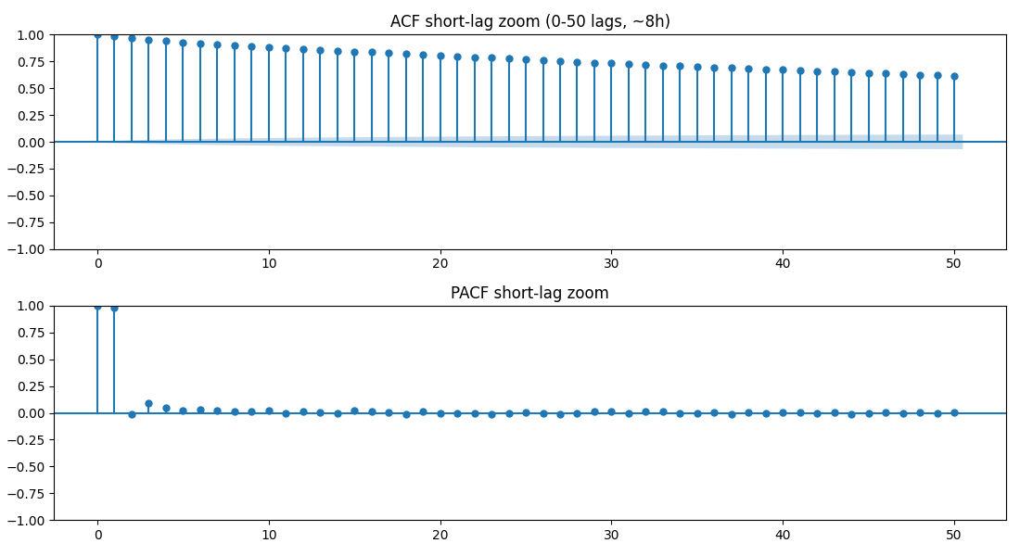
Figure 12. ACF and PACF, short-lag zoom (0-50 lags ≈ 0-8.3 hours).
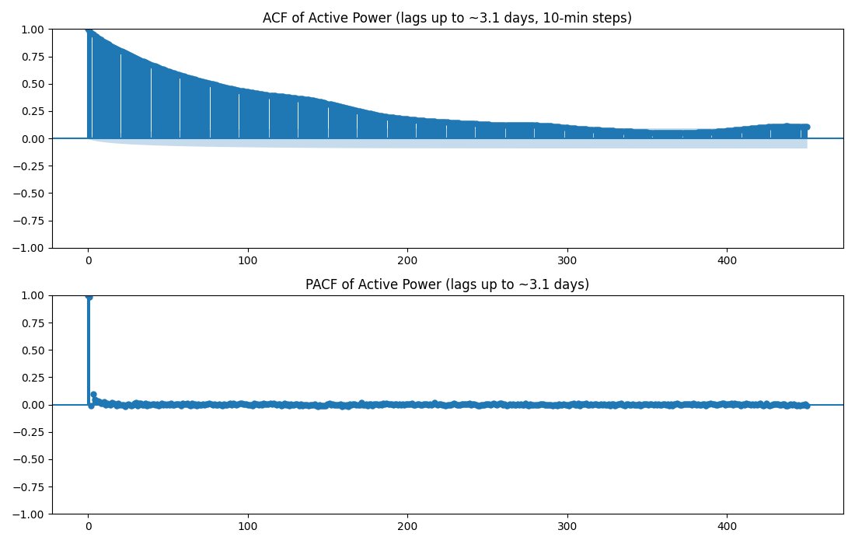
Figure 11. ACF and PACF out to ~450 lags (≈3.1 days).
- ACF decays slowly and smoothly from ~1.0, remaining well above the significance band out past 3 days of lag — classic signature of strong short-to-medium-term persistence (the power level right now is highly informative about the power level minutes to hours from now, because wind speed itself is persistent).
- PACF shows a very large spike at lag 1 with a sharp drop-off, and smaller but non-trivial spikes at subsequent low lags — consistent with the series' short-term dynamics being dominated by a strong AR(1)-like component plus additional higher-order structure.
- Neither plot shows the sharp periodic 'comb' pattern at lag ≈144 (1 day) that would indicate strong deterministic daily seasonality; the persistence looks more like a smoothly decaying, weather-driven autocorrelation than a clean seasonal cycle.

6. Signal Characteristics

Periodicity
Weak. The FFT (Section 7) shows a modest peak near a 24-hour period, but its magnitude is far smaller than the low-frequency (multi-day to seasonal) components, and no sharp harmonic comb (24h, 12h, 8h, ...) dominates the spectrum. The hourly boxplot (Fig. 9) corroborates this — medians by hour of day are close together.

Randomness
Not purely random. A white-noise / IID series would show ACF collapsing to ~0 after lag 1; instead ACF stays significantly above zero for hundreds of lags (Fig. 11), so there is substantial short-to-medium-range structure. At the same time, the year-long trace (Fig. 6) and one-week zoom (Fig. 10) show irregular, non-repeating fluctuation at the finest time scale — the raw 10-min signal is a mix of a persistent, structured component (wind's own autocorrelation, mediated non-linearly through the turbine's power curve) and finer irregular fluctuation.

Nonlinearity
Present by construction. The scatter of Power vs. Wind Speed (Fig. 5, left) is a clear S-shaped (sigmoidal) curve, not a straight line: near-zero output below cut-in, a steep cubic-like ramp through the mid-range, and a flat plateau at rated capacity. Spearman correlation (0.933) exceeding Pearson (0.913) for Power↔Speed is additional quantitative evidence of monotonic-but-nonlinear coupling.

Long-term dependency
Some evidence, moderate confidence. ACF remaining elevated out to ~3 days (the longest lag inspected) suggests dependency beyond simple short-range autocorrelation, and the weekly rolling mean visibly drifts across the year (seasonal-scale memory). Confirming genuine long-memory (e.g., a slowly-decaying power-law ACF, as opposed to a sum of several exponentials) would need a dedicated Hurst-exponent or long-memory (e.g., GPH/Whittle) estimation, which was outside this pass.
Hypothesis (needs further validation): Long-range dependence beyond a few days should be tested explicitly (e.g., Hurst exponent, R/S analysis, or fractional-differencing tests) before being relied on for modeling choices.

Nonstationarity
Mixed/moderate evidence, resolution-dependent. ADF rejects a unit root at both raw and daily resolution, but KPSS flags the raw series as non-level-stationary (Section 5.2) — most plausibly reflecting the volatility clustering and multi-day weather regime shifts visible in Fig. 7 (rolling std is itself time-varying) rather than a deterministic trend. At the daily-aggregate scale, both tests agree the series is effectively stationary.

Irregular fluctuations
Clearly present. Beyond ordinary sensor noise, the data contains 231 distinct episodes (Section 2.4) where power drops to ~0 kW despite wind speeds above typical cut-in — abrupt, non-smooth departures from the expected power-curve behavior, visible as the dense band of negative deviations in Fig. 15. These are the most conspicuous 'anomalous' fluctuations in the dataset and are almost certainly operational (curtailment/downtime/fault) rather than measurement noise, given their clustering into sustained runs.

7. Frequency Analysis
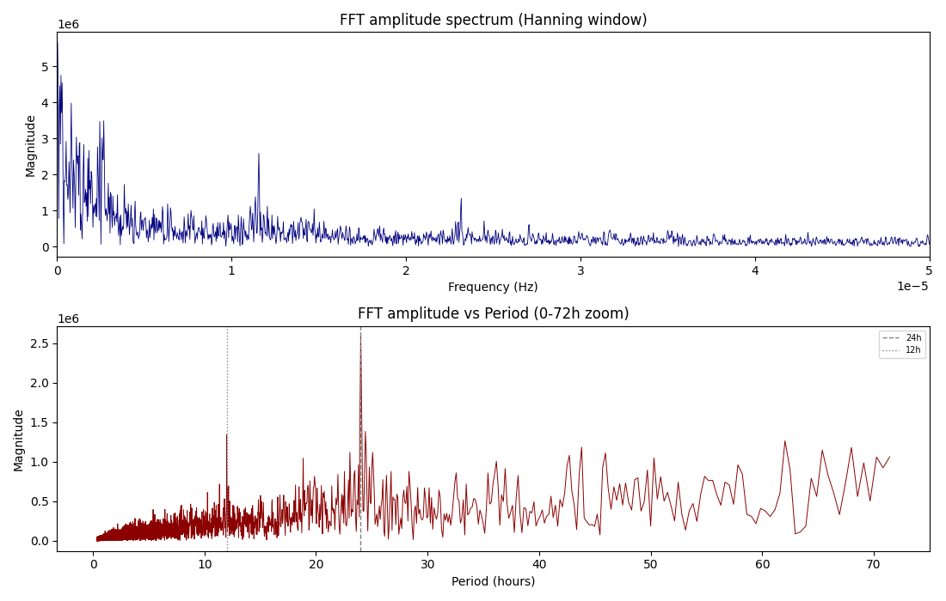
Figure 13. FFT amplitude spectrum of the (gap-interpolated, uniformly-sampled) Active Power series. Top: full frequency range. Bottom: same spectrum re-plotted against period in hours, zoomed to 0-72h, with 24h and 12h reference lines.
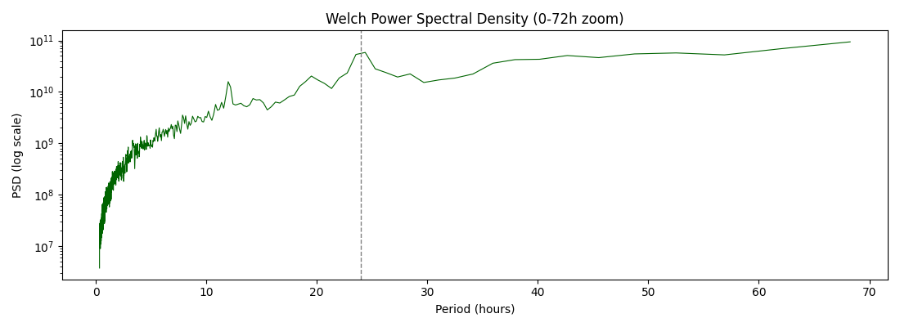
Figure 14. Welch power spectral density estimate (log scale), 0-72h period zoom.
- The series was reindexed onto a strictly uniform 10-minute grid and small gaps (≤50 samples) linearly interpolated before FFT/PSD to avoid spectral leakage from the irregular timestamp spacing noted in Section 1.2 and Section 5.2's gap analysis.
- The dominant spectral energy sits at very long periods (hundreds to thousands of hours, i.e., multi-week to seasonal scales) — magnitude at these bins (≈3-6 million) dwarfs everything shorter, confirming the low-frequency trend/seasonality seen in the time-domain plots is the single largest source of variance.
- A local peak exists at 24.0h (magnitude ≈2.59 million) and a smaller one at 12.0h (≈1.05 million) — both well above the spectral floor (median magnitude ≈21,000 across all bins), confirming a real but modest diurnal periodicity, consistent with the mild hour-of-day effect in Fig. 9.
- There is no isolated, sharply dominant single frequency — the spectrum is broadband with a red-noise-like (energy concentrated at low frequencies) shape, consistent with a wind-driven process rather than a deterministic periodic signal or a rotating-machinery vibration signal (which would typically show narrow, high-frequency mechanical harmonics not present in this 10-minute-resolution SCADA data).
Hypothesis (needs further validation): Wavelet analysis (e.g., continuous Morlet wavelet transform) was not performed in this pass but would help localize *when* the diurnal/multi-day periodic components strengthen or weaken across the year, given the volatility clustering already observed in Fig. 7.

8. Feature Engineering Suggestions

8.1 Statistical / Rolling Features
- Rolling mean, std, min, max of Active Power and Wind Speed over multiple windows (1h, 6h, 1 day, 1 week) to capture the multi-scale persistence seen in the ACF.
- Lag features (t-1, t-6, t-144) for Active Power and Wind Speed, informed by the PACF spike structure.
- Rolling skewness/kurtosis to flag regime changes (e.g., transitions into/out of curtailment episodes).
- Time-since-last-zero-power and run-length-of-current-state features, directly targeting the shutdown-episode behavior identified in Section 2.4.

8.2 Signal-Processing Features
- Spectral band-power features (e.g., energy in the 20-28h period band vs. the >168h band) as engineered predictors of local regime.
- Wavelet-based multi-resolution energy features (per Section 7's suggested follow-up) to capture non-stationary periodicity strength over time.
- Rate-of-change / first-difference of Wind Speed and Active Power, and their rolling variance, as proxies for turbulence intensity.

8.3 Domain / Physics-Informed Features
- Deviation from the theoretical power curve at the observed wind speed (Actual − Theoretical, as plotted in Fig. 15) — directly usable as a curtailment/underperformance indicator or anomaly-detection target.
- Binary/categorical cut-in, ramp, rated, and cut-out regime flags derived from wind-speed thresholds, since the power relationship is piecewise in nature (Fig. 5).
- Circular encoding of Wind Direction (sin/cos transform) rather than raw degrees, given its circular topology and the two-sector wind-rose structure (Fig. 16).
- Interaction term between wind direction sector and wind speed (possible wake-loss proxy), motivated by direction's weak marginal but potentially non-trivial conditional effect on power.

9. Visualizations
All figures referenced throughout this report are collected below for reference (Figures 1-16). See the inline captions in Sections 3-7 for the explanation accompanying each plot; this section exists as a consolidated index rather than a duplicate of the plots themselves.
# | Figure | Section
1 | Histograms + KDE (all variables) | 3 Distribution
2 | Boxplots | 3 Distribution
3 | Violin plots | 3 Distribution
4 | Correlation matrices (Pearson/Spearman) | 4 Relationships
5 | Power vs. wind speed / direction scatter | 4 Relationships
6 | Full-year time series + rolling means | 5 Time series
7 | Rolling standard deviation | 5 Time series
8 | Monthly boxplot | 5 Time series
9 | Hourly boxplot | 5 Time series
10 | One-week zoom | 5 Time series
11 | ACF/PACF, long lag | 5 Time series
12 | ACF/PACF, short lag | 5 Time series
13 | FFT amplitude spectrum | 7 Frequency
14 | Welch PSD | 7 Frequency
15 | Power curve deviation | 4 / 6
16 | Wind rose | 4 Relationships

10. Findings

10.1 Important Patterns
- The dataset is a single wind turbine's SCADA record for a full calendar year at 10-minute resolution (~3.6 MW rated capacity).
- Active Power is driven overwhelmingly by Wind Speed via a non-linear (S-shaped) power curve (Pearson r=0.91, Spearman ρ=0.93 with Wind Speed; r=0.95 with the theoretical curve); Wind Direction is only weakly, likely indirectly, related to power.
- Variance is multi-scale: strong sub-daily/multi-day persistence (slow-decaying ACF), a genuine but modest ~24h periodic component (FFT), and dominant seasonal/multi-week scale variation (largest spectral peaks; drifting monthly boxplots).
- Wind direction is bimodal (two dominant sectors, wind rose), suggesting a prevailing-wind site.

10.2 Anomalies
- 57 slightly-negative power readings (idling/parasitic-load noise, physically minor).
- 231 distinct episodes (1,788 samples total) of near-zero power despite above-cut-in wind speeds, up to ~44.5 hours long — the most operationally significant anomaly in the data, most consistent with curtailment, downtime, or a grid/fault condition.
- One large ~4.3-day timestamp gap (Jan 26-30, 2018) and ~30 smaller gaps in the logging cadence.

10.3 Potential Challenges
- Mixed stationarity signal at raw (10-min) resolution (ADF vs. KPSS disagreement) driven by volatility clustering — models assuming strict stationarity at that resolution should account for time-varying variance (e.g., GARCH-style variance modeling or working at a coarser/aggregated resolution).
- Curtailment/downtime episodes will bias any model trained to predict power purely from wind speed unless explicitly flagged or filtered, since they represent non-physical, operationally-driven zero-power periods rather than the turbine's true response to wind.
- Irregular timestamp gaps require reindexing/interpolation (or gap-aware modeling) before any lag-based or spectral method is applied, as done in Section 7.
- Wind Direction's circular topology (0°≈360°) means it must be transformed (sin/cos) before use in most models or distance-based methods.

10.4 Recommended Preprocessing
- Reindex to a uniform 10-minute grid; interpolate short gaps, and explicitly flag/exclude the long January outage rather than interpolate across it.
- Engineer and flag the ~231 zero-power/high-wind episodes as a separate curtailment/downtime indicator; consider modeling them separately from normal operation.
- Circular-encode Wind Direction (sin/cos).
- Consider log/Box-Cox or power-curve-relative transforms of Active Power to address its right-skew and bounded, S-curve-linked structure.
- Build the lag/rolling/spectral features suggested in Section 8 before modeling.

10.5 Suitable Downstream ML Models
- Power-curve regression / short-horizon forecasting: gradient-boosted trees (XGBoost/LightGBM) or random forests on engineered lag + rolling + wind-speed/direction features — well suited to the strong non-linear but not overly high-dimensional relationship found in Section 4.
- Sequence models: LSTM/GRU or Temporal Convolutional Networks for multi-step-ahead power forecasting, given the demonstrated multi-scale autocorrelation (Section 5.3) and mild periodicity (Section 7).
- Classical time-series models: SARIMA (with a 144-lag seasonal term to test the weak daily cycle) or a state-space/UCM model with a slow trend + weak diurnal seasonal + irregular component, motivated directly by the ADF/KPSS and ACF findings.
- Anomaly/curtailment detection: an isolation forest or a simple rule/threshold model on (Actual − Theoretical) power deviation (Fig. 15) to automatically flag the shutdown episodes identified in Section 2.4/6.
- If long-range dependence is confirmed (Section 6), fractional-ARIMA or other long-memory-aware models may outperform standard short-memory approaches for very long-horizon forecasts.

